ANNOUNCEMENTS

Following on from the recent reporting changes in the European and North America management structure, I am pleased to advise that the organizational structure in Asia will be changed as follows with immediately effect.

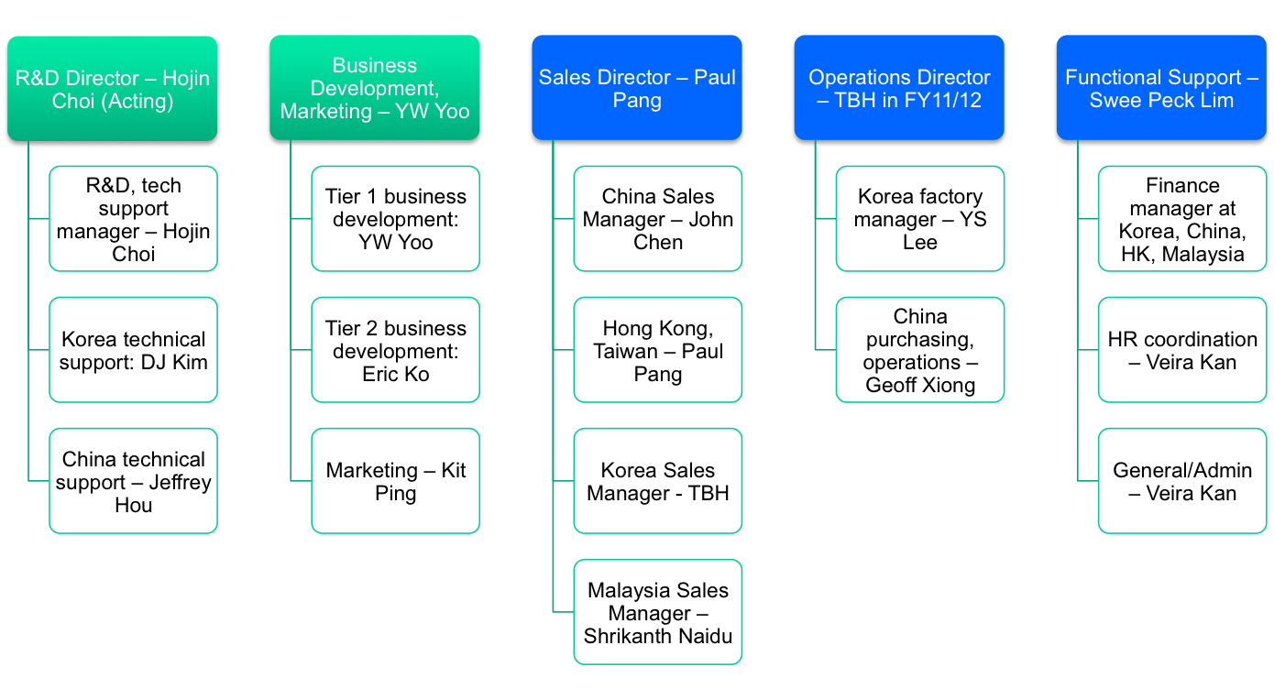
The following appointments are announced as part of this change:-

Hojin Choi is appointed Acting R & D Director, providing R&D/Technical support.

Yeongwook Yoo is appointed as Director of Asia Business Development. Yeongwook who joined us on 31st of May 2010, graduated from Seoul National University with a Bachelor of Art Degree in Economics. He has extensive experience in key account management, business development, management consulting, corporate planning and finance with Cisco Systems, Arthur D. Little, and SK Telecom. His extensive knowledge and experience in high tech sector and account management experience will accelerate Asia/Electronics BU business expansion.

I take this opportunity to welcome Yeongwook and wish him every success in his career with Scapa to create and drive various strategic accounts and projects.

The Operations Director position remains vacant at the moment and until a successor is in place, YS Lee, Factory Manager will be managing the daily activities of the Korean factory.

Paul Pang is appointed as Sales Director responsible in managing all our sales teams in Asia and will carry the responsibility of Country Manager for Greater China as well.

Swee Peck Lim is appointed as Country Manager for Malaysia and will provide financial and various functional support towards the Asia business.

These positions will all report to me and I will also assume the Country Manager role for South Korea in the interim.

As part of our strategy to consolidate our position and resources, the Scapa Taiwan Sales Office will be closed with effect from July 2010. Our Hong Kong office will extend its service and support to Taiwan’s existing business and to new enquiries from that region.

I trust you will give your full support towards the vibrant success of the Asia Team in their new roles.

Gene Kim
Managing Director Asia
2 June 2010

